**ACTIVITY 9**

**NAME : M.Varshini COURSE: MOBILE COMPUTING**

**REG NO : 192421293 COURSE CODE: ITA0302**

9. Develop a user interface prototype for a GSM service using Figma.

**Aim:**

To develop a user interface prototype for a GSM service using Figma.

**Procedure:**

1. Open Figma

2. Create a new file

3. Select the Frames

4. Fill in the content that is required for presentation

5. Design Visual Elements

6. Make it Interactive

7. Add Annotations and Explanations

8. Incorporate Multimedia

9. Storyboard Animation

10. Review and edit the Prototype

11. Save and Share

**Design:-**

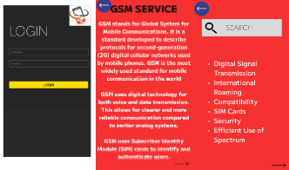

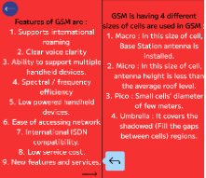

Prototype:

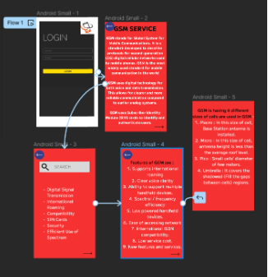

**Result:**

Hence developed a user interface prototype for a GSM service using Figma.